PA5

Program Flow

* Begins with Facial Recognition
  + Performs Facial Recognition analysis for each subject
  + Uses a handful of images to test for recognition accuracy
  + Tries using LBP feature vector, Integral Image feature vector, image feature vector and then all of them combined in that order to show the variation in accuracy
  + Prints accuracy as a percentage for each feature vector or combination used

SAMPLE RESULTS:

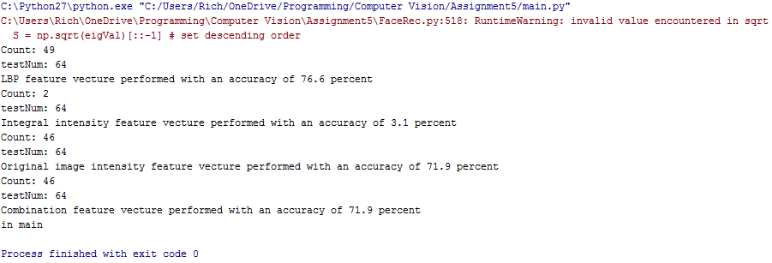

Resources:

<http://programmingcomputervision.com/downloads/ProgrammingComputerVision_CCdraft.pdf> (pg. 27)

<https://en.wikipedia.org/wiki/Eigenface>

<http://face-rec.org/algorithms/PCA/jcn.pdf>

Hints from professor

After obtaining images (integral or whatever feature extraction you have done),   
1) construct your matrix row-column format, image features are vectorized  
2) construct covariance matrix from (1)  
3) do eigenvalue analysis, find eigenvalues in descending orders and their eigenvectors  
4) select appropriate eigenvalues higher than value 1 (or 98% rule is also fine)  
5) simplify the matrix now with those eigenvectors corresponding to eigenvalues  
6) for any given image do the step 1, and you have now only one vector.   
7) now use the vector in 6 and the matrix in 5 to do comparison. use distance computation to choose which face is closest

* Begins Graph-cut Image Segmentation
  + Reads images out of GraphCutImages folder (Note* all images placed in that folder will be automatically segmented)
  + Asks for user input
    - Click in 2 different areas to seed data into interactive algorithm
    - The image should close and continue to next step
  + Calculate histogram
    - Since the histogram is used as the likelihood function we calculate and display them (likelihood maps)
    - The map will then be displayed onto the screen and program will not progress until it is closed (only background histogram is shown, the foreground is a constant number, although it is calculated as 1 – background histogram (with 1 being original image))
  + Calculate unary weights
    - Defines unary term to be used with Energy function
  + Calculate Pairwise weights
    - Defines pairwise term to be used with energy function
  + Define Energy function and segment
    - Defines energy function using sum of unary and pairwise terms
  + Displays final segmented image
    - The foreground pixels are shown in their original colors while the background pixels are shown in red

Sample Results:

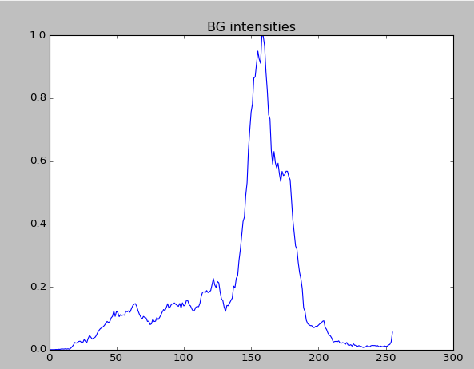 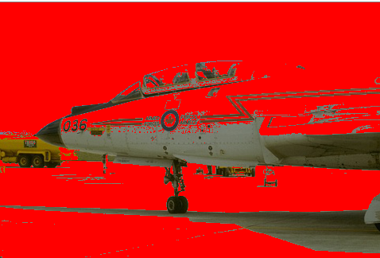

Resources:

**Computer Vision -- ECCV 2014: 13th European Conference (Google book)**

[**https://courses.engr.illinois.edu/cs543/sp2011/lectures/Lecture%2012%20-%20MRFs%20and%20Graph%20Cut%20Segmentation%20-%20Vision_Spring2011.pdf**](https://courses.engr.illinois.edu/cs543/sp2011/lectures/Lecture%2012%20-%20MRFs%20and%20Graph%20Cut%20Segmentation%20-%20Vision_Spring2011.pdf)

**Max flow Documentation and source code on home page**

**Github source code**